To establish learning ambience for ushering in computer engineering professionals in core and multidisciplinary area by developing Problemsolving skills through emerging technologies.

Session | 2025-26 (ODD) | Course Name | Operating System Lab
Semester | 5 | Course Code | 23IOT1504
Roll No | 40 | Name of Student | Harsh saawalakhe

Practical Number | 8
Course Outcome | - Understand Computer System Configuration and Simulate system resources efficiently using Linux Commands (CO1)  - Analyse operating system functionalities utilizing system calls, thread programming and process scheduling algorithms (CO2)  - Apply Synchronization primitives to implement a Deadlock-free solution(CO3)  - Simulate Disk scheduling, Memory allocation, File allocation, page replacement algorithms (CO4)
Aim | Develop a program to provide synchronization among the 5 philosophers in the Dining Philosophers Problem using semaphores.
Problem Definition | To implement synchronization among 5 philosophers sitting around a circular table, ensuring no two neighboring philosophers eat simultaneously using semaphores to avoid deadlock and starvation.
Theory | The Dining Philosophers Problem illustrates synchronization and resource-sharing issues in concurrent systems.  - Scenario:  Five philosophers sit at a round table. Each philosopher alternates between thinking and eating.  Between each pair of philosophers lies a single fork (shared resource).  - Constraint:  A philosopher must pick up both left and right forks to eat.  - Objective:  Avoid deadlock (where all philosophers hold one fork) and starvation (some never get to eat).
To establish learning ambience for ushering in computer engineering professionals in core and multidisciplinary area by developing Problemsolving skills through emerging technologies.

Semaphore Concept:
Semaphores are synchronization primitives used to manage access to shared resources in concurrent systems.
Two main operations:
- wait(s): Decrements the semaphore value (block if zero).
- signal(s): Increments the semaphore value (wake up waiting process).

States of Philosopher:
- THINKING
- HUNGRY
- EATING
Give Procedure and Execution  (100 Words) | - Initialize an array of semaphores representing each fork.  - Each philosopher runs as a separate thread.  - Before eating, a philosopher performs wait() on the left and right fork semaphores.  - After eating, the philosopher performs signal() to release both forks.  - Mutex is used to ensure atomic access to shared states, preventing race conditions.  - The cycle continues to demonstrate synchronization and avoidance of deadlock.
Give Procedure and Execution  (100 Words) | Code:  #include <stdio.h>  #include <pthread.h>  #include <semaphore.h>  #include <unistd.h>  #define N 5  #define THINKING 0  #define HUNGRY 1  #define EATING 2  #define LEFT (phnum + 4) % N  #define RIGHT (phnum + 1) % N  int state[N]; int phil[N] = {0, 1, 2, 3, 4};  sem_t mutex; sem_t S[N];
To establish learning ambience for ushering in computer engineering professionals in core and multidisciplinary area by developing Problemsolving skills through emerging technologies.

void test(int phnum) {
if (state[phnum] == HUNGRY && state[LEFT] != EATING &&
state[RIGHT] != EATING) {

state[phnum] = EATING; printf("Philosopher %d takes forks %d and %d\n", phnum + 1, LEFT + 1, phnum + 1); printf("Philosopher %d is Eating\n\n", phnum + 1); sem_post(&S[phnum]);
}
}

void take_fork(int phnum) { sem_wait(&mutex); state[phnum] = HUNGRY; printf("Philosopher %d is Hungry\n", phnum + 1); test(phnum); sem_post(&mutex); sem_wait(&S[phnum]);
}

void put_fork(int phnum) { sem_wait(&mutex); state[phnum] = THINKING; printf("Philosopher %d puts down forks %d and %d\n", phnum + 1, LEFT
+ 1, phnum + 1);
printf("Philosopher %d is Thinking\n\n", phnum + 1); test(LEFT); test(RIGHT); sem_post(&mutex);
}

void* philosopher(void* num) {
int* i = num; for (int k = 0; k < 2; k++) { // each philosopher eats 2 times sleep(1); take_fork(*i); sleep(2); put_fork(*i);
}
return NULL;
}
To establish learning ambience for ushering in computer engineering professionals in core and multidisciplinary area by developing Problemsolving skills through emerging technologies.

int main() {
int i;
pthread_t thread_id[N];

sem_init(&mutex, 0, 1); for (i = 0; i < N; i++)
sem_init(&S[i], 0, 0);

for (i = 0; i < N; i++) { pthread_create(&thread_id[i], NULL, philosopher, &phil[i]); printf("Philosopher %d is Thinking\n", i + 1);
}

for (i = 0; i < N; i++) pthread_join(thread_id[i], NULL);

printf("\nAll philosophers have finished eating.\n"); return 0;
}

To establish learning ambience for ushering in computer engineering professionals in core and multidisciplinary area by developing Problemsolving skills through emerging technologies.

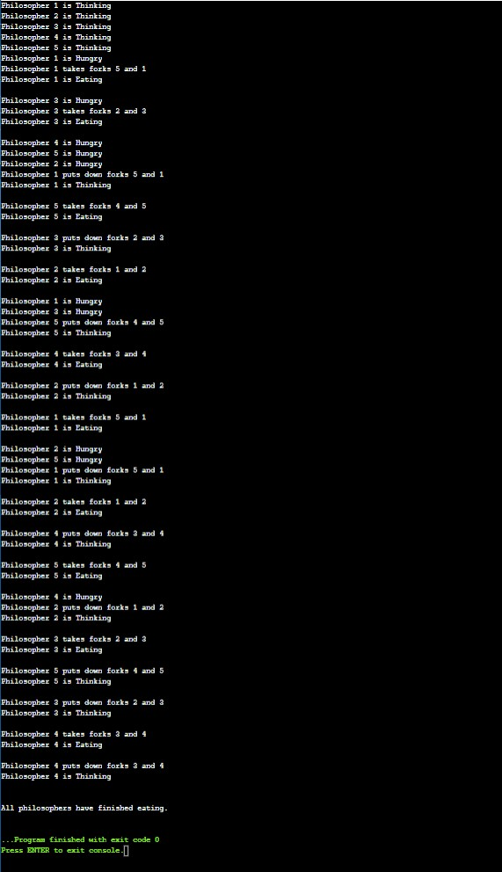
Output

:

Mission of the Department
To establish learning ambience for ushering in computer engineering professionals in core and multidisciplinary area by developing Problemsolving skills through emerging technologies.

Output Analysis | The output shows that only one philosopher at a time can eat, and no two adjacent philosophers eat simultaneously.  This ensures proper synchronization, preventing deadlock and starvation using semaphores.
Link of student Github profile where lab assignment has been uploaded | https://github.com/harsh-s222/operatingsystem/upload/main
Conclusion | Successfully developed a program for Dining Philosophers Problem using semaphores to achieve synchronization. The implementation prevents deadlock and ensures mutual exclusion among philosophers.
Plag Report  (Similarity index <  12%) | 
Date | 27/10/25

